**ECE 792/CSC 791 - LINUX NETWORKING**

**VIRTUAL PRIVATE CLOUD – DNS AS A SERVICE**

**FINAL PROJECT REPORT**

**TEAM MEMBERS**

**Harish Annamalai Palaniappan - hpalani**

**Jagadeesh Saravanan – jsarava**

**Ragavi Swarnalatha Raman – rraman2**

**Sampreetha Naattamai Sureshbabu - snaatta**

**DNS as a Service:**

Our Cloud DNS is a reliable,scalable and managed hierarchial DNS service that can be used in a Virtual Private Cloud Environment to set up Private Hosted Zones ie)DNS servers at various points in the private L2 network. The created DNS system enables the usage of private domain names for the servers/machines inside the VPC and translates the requests for the domain names into their corresponding IP addresses.

Our DNS solution is an automated application that enables a VPC owner to configure DNS servers as per requirement in various subnets. The application auto-generates Forward and Reverse zone files for the subnets in the DNS server and enables access of servers in the VPC through URLs in addition to their IP addresses. Our application can also configure DNS service across multiple sites that form a part of the VPC through GRE Tunneling.

Project Proposal Document: [Click Here](https://drive.google.com/file/d/1guVj-3eSGe2oq9EfYuwQp2TTz8X7w3Kg/view?usp=sharing)

**System Architecture:**

* The system architecture contains two separate hypervisors with L2 Bridges to which Virtual Machines and namespaces are connected to.
* The Virtual Machines and Namespaces act as the clients , servers and DNS servers.
* GRE Tunneling is used to connect the two hypervisors to make it appear as if they exist in the same Private Network.

A general overview of the system interaction during the Name resolution is as follows:

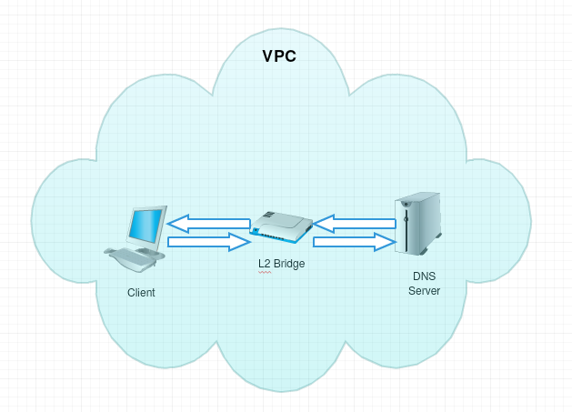

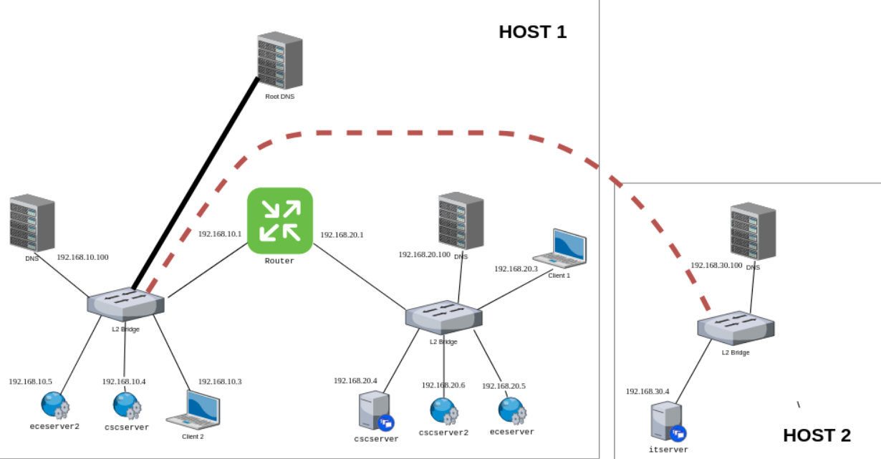

**Feature Architecture:**

**1. Name Resolution within Zones**

DNS server resolves the name and provides corresponding IP address configured. For example, Client 1 contacts the DNS to reach the ece server using www.ece.univ.edu. DNS resolves the address by giving the IP of any of the configured ece server. Now the client can directly reach the ece server using the obtained IP address.

**2. Load Balancing of Servers**

This feature balances traffic between several web servers that carry the same content/run the same application. The DNS server to which the request is made does load balancing and distributes the request by returning an IP address from the set mapped to the same domain name in a round robin basis.

**3. Location/Source IP Based Aware Resolution**

When the VPC offers a service / runs an application on a number of identically configured servers that are distributed across several subnets for redundancy / easy access purpose and the servers need to be reachable using a single domain name , but at the same time the DNS request needs to point users to the server that is closer / present in the same subnet as the client itself we use a Location Aware / Content Based Resolution.

**4. High Availability / DNS Failover**

When the client queries a DNS and finds that it is shutdown/ failed, then the next entry of DNS in /etc/resolv.conf file is queried for the name resolution.

**Implementation:**

**Clients and Web Servers :**

Clients and Web Servers are either VMs installed using libvirt module on the L2 bridges or namespaces created in the hypervisor and attached to the L2 bridge using veth pairs

**DNS Server:**

BIND name server software is used to set up an internal DNS server which can resolve private host names to their IP addresses. Clients within the same or different subnet contact this DNS server to reach the web servers.

Steps to configure BIND as private network DNS Server:

1. Install BIND9 on DNS servers
2. Configure BIND

Edit /etc/named.conf file to create a new Access Control Lists which includes clients/subnets that can query the DNS. List the forward and reverse zone files that are to be fetched during resolution.Add the private address of Nameserver (NS) to list of addresses that listen on port 53.

4. Create Forward zone file

The forward zone file defines the DNS records for forward DNS lookups. That is, when the DNS receives a name query, it looks in the forward zone file to resolve the server’s corresponding private IP address. Edit the file db.<forward zone> file to add SOA, name server and A records (for nameserver and hosts).

5. Create Reverse zone file

Reverse zone file is used to define DNS PTR records for reverse DNS lookups. That is, when the DNS receives a query by IP address, it looks in the reverse zone file(s) to resolve the corresponding Fully Qualified Domain Name (FQDN). Edit the db.<reverse zone> file to add SOA, name server and PTR records (for all servers whose IP addresses are on same subnet of zone file).

6. Check BIND configuration syntax

7. Start BIND

Primary DNS server is now setup and ready to respond to DNS queries.

8. Configure DNS clients

Before the servers identified in the ACL can query the DNS servers, they must be configured to use new nameservers.

9. Test Clients

In the DNS server, test the forward and reverse lookups using nslookup utility.

**Router:**

The Router is implemented as a virtual machine with static routes that enable routing between different subnets in the VPC.

**Feature Implementation:**

1. **Resolution within Zones:**

The DNS server that resides in a subnet is configured such that it is capable of resolving the IP addresses of Web Servers that reside in other subnets within the Private Network.

The steps involved are:

1. The different zones/subnets are listed in the named.conf file.

2. Separate forward and reverse resolution files for each subnet are created with mapping entries of the servers present in that subnet.

3. Replicate the forward and reverse resolution files in all the DNS servers that needs to do the DNS resolution

4. Configure the client’s resolv.conf file to point to the name server present in the same subnet / different subnet.

**2. Load Balancing of Servers:**

1. Add the IP addresses of the servers under the same domain name as records in the Forward and reverse resolution zone files.

2. Replicate the forward and reverse resolution files in all the DNS servers that needs to do the DNS resolution

3. Configure the client’s resolv.conf file to point to the required DNS server.

**3. Location / Source IP Based Resolution :**

We implement the Location Aware resolution with the help of views. Views allow to define different virtual configurations within the same server and also to specify which client should be sent which IP addresses as response for a DNS resolution request. The steps involved are :

1. Add the subnets that need to be resolved under separate ACLs in the named.conf file

2. Create views that match the acl and the resolution database that much be fetched on a request from the clients in the corresponding acl.

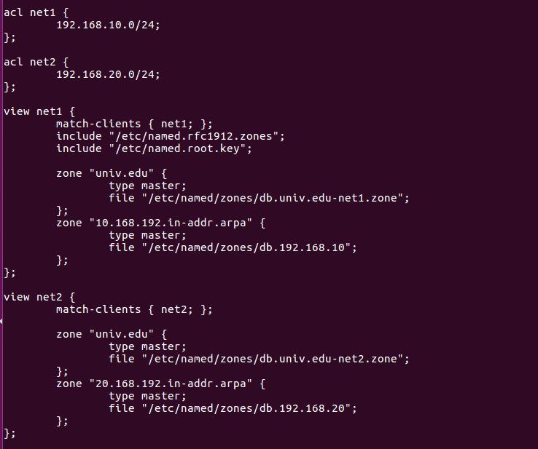

3. Create forward and reverse resolution files for the views created in the named.conf with the IP and domain name mapping.

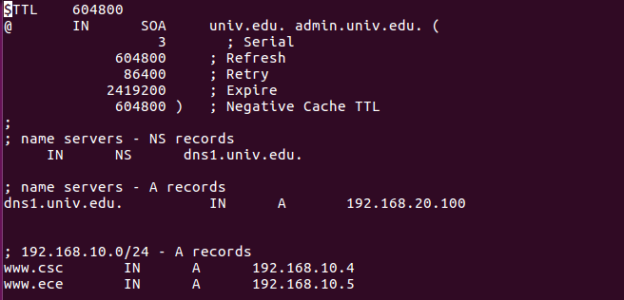

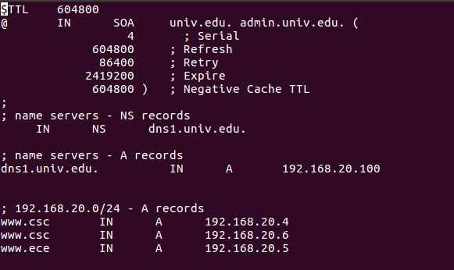

3. Replicate the forward and reverse resolution files in all the DNS servers that needs to do the DNS resolution.

4. Configure the client’s resolv.conf file to point to the required DNS server.

**4. High Availability / DNS Failover**

1. A secondary DNS server is configured with same configurations in the named.conf file and the database files for each zone.

2. The client’s resolv.conf should contain both the name server’s IP address as records to look for whenever a resolution request is sent out.

**5. Phishing Prevention:**

1. A namespace that acts a client whose DNS resolution requests should be dropped is created.

2. The ip tables of the DNS server is modified by adding an INPUT chain rule.

Iptables -I INPUT -p udp --dport 53 -s <client ip> -j DROP

Iptables -I INPUT -p tcp --dport 53 -s <client ip> -j DROP

3. Configure the client’s resolv.conf file to point to the DNS server

4. When the client makes a request, the DNS server now drops the request.

**Containers :**

DNS servers are containers with a custom Centos image that has all tools installed including bind-utils, systemctl etc

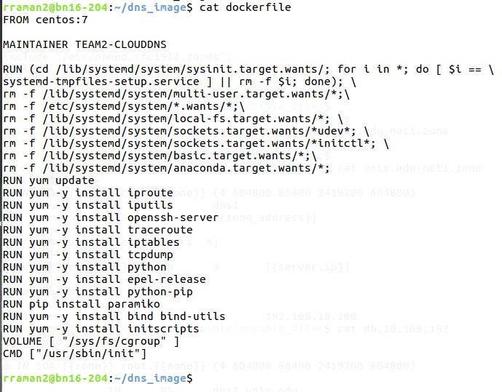

The servers and client in the VPC are base ubuntu images with ip tools and ping tool installed.

**GRE tunnel in OVS Bridges:**

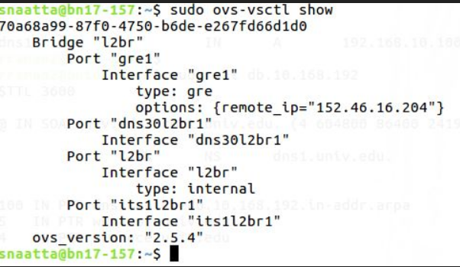

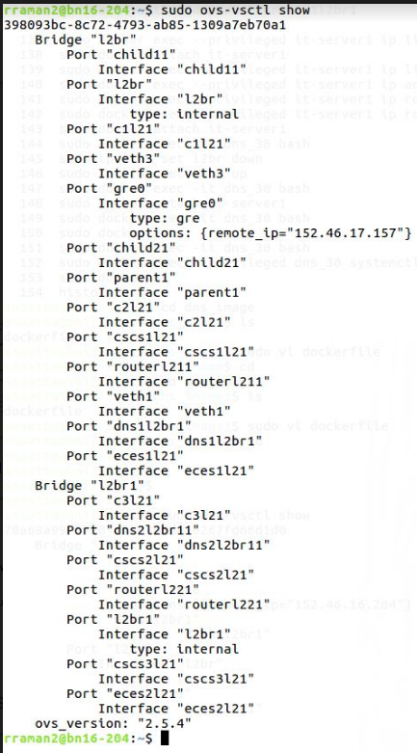

**Automation:**

To automate the entire DNS configuration inside the VPC, a Python application is implemented that gets input from the user through a Northbound interface and communicates the data to the DNS configuration Ansible through a south bound interface.

First Level of Automation:

* Assuming that the customer has a fully setup VPC ready and reachable and ready to configure additional DNS servers, the application gets the subnets in which the DNS servers need to be configured followed by the number of DNS servers.
* The IP address plan of the existing VPC is read by the application as a config file in python
* A parent DNS that creates a hierarchy DNS service and that forwards the DNS request to the authoritative DNS servers in each subnet.
* Authoritative DNS servers that resolve the URLs to IP addresses are created
* Both the DNS servers are containers in the hypervisors.

Figure : The Python Application that gets VPC info and subnet plan from User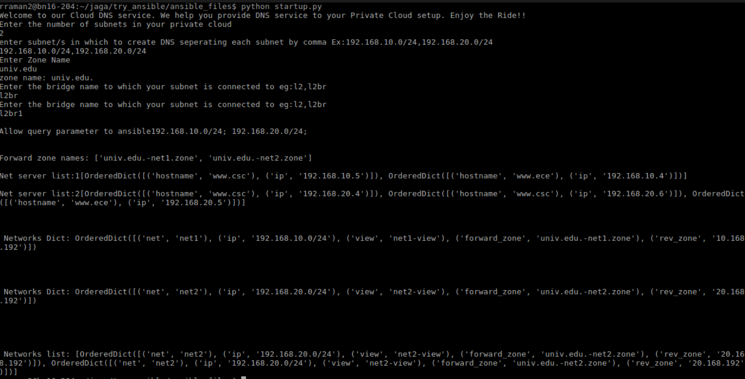

Second Level of Automation:

Ansible:

* Ansible receives the IP address plan and the DNS config data from the Python application
* Bind9 module of Ansible is used to install these configurations in the created DNS servers.
* The yaml file is ran with the host as the ip address of the DNS container
* DNS service is started and ensured that NSlookup happens.

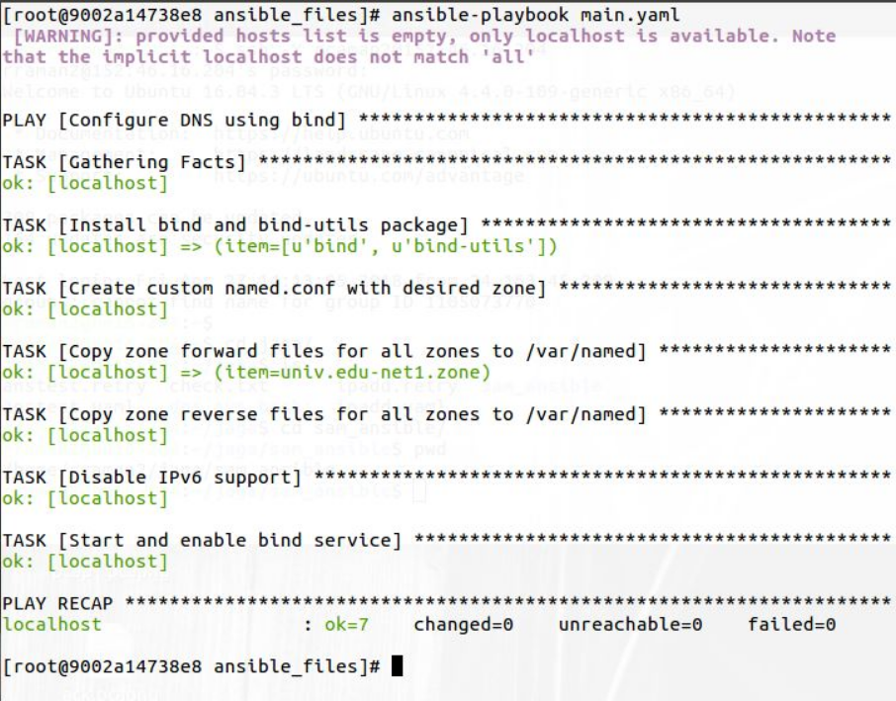

**Validation:**

1. **Resolution from same Subnet:**

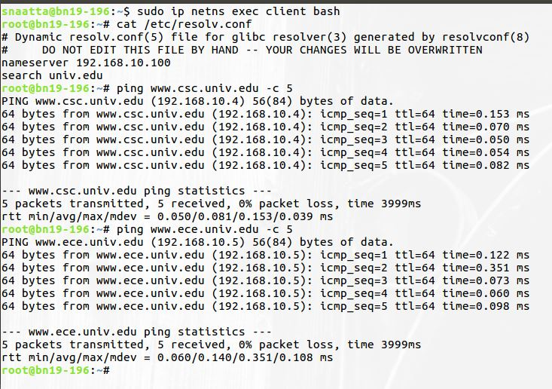

When the client pings www.csc.univ.edu, DNS resolves the domain name by providing the IP address (192.168.10.4). Similarly when the client pings www.ece.univ.edu, it reaches 192.168.10.5. Therefore, the IP address are properly resolved by the DNS server that shows all the configurations in client and DNS server are perfect.

**2. Load Balancing among Servers:**

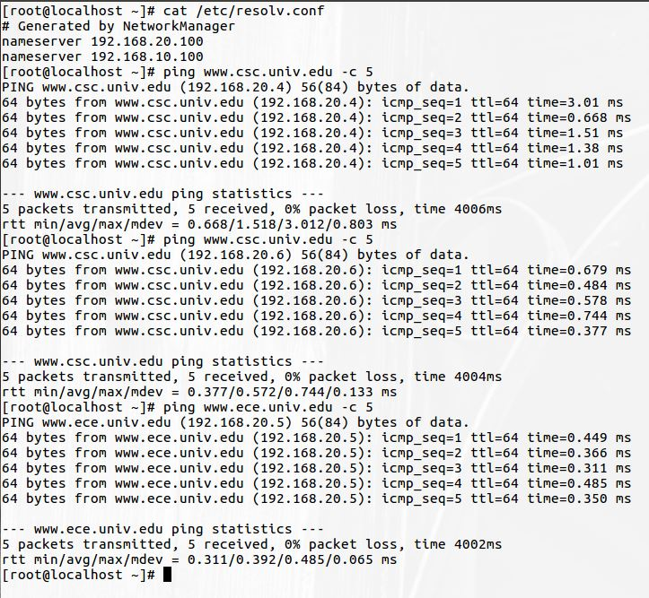

Here load balancing scenario is depicted. Above screenshot shows that when a client first tries to reach www.csc.univ.edu, DNS resolves this query with 192.168.20.4 as the IP address. Next time when the client tries to reach the same address, DNS provides the IP as 192.168.20.6. Round-robin fashion is followed by the DNS in resolving the names.

**3. Logs for the DNS Resolution (/var/log/messages)**

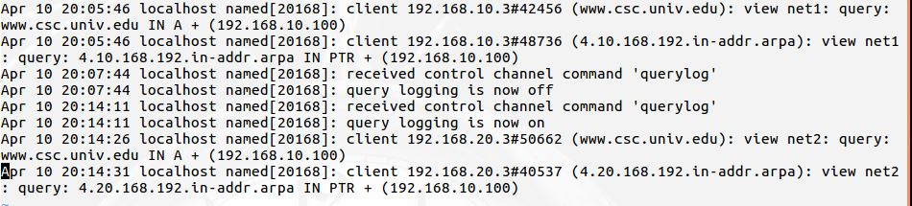

Logs for forward and reverse look up is recorded using name server control utility, RNDC. When the client from different subnet queries the DNS, appropriate A records are fetched.

**4. High Availability/ DNS Failover:**

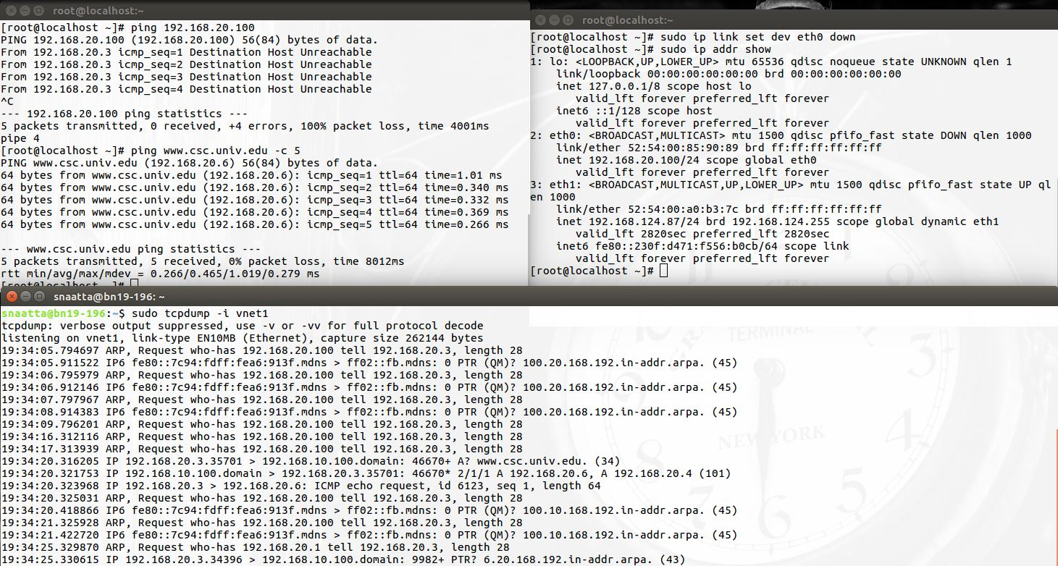

To demonstrate HA, the link to DNS server (192.168.20.100) is set down and the client still able to ping www.csc.univ.edu via the other DNS server. This depicts our DNS services are made highly available by having multiple DNS servers. Log screenshot is also attached to show that DNS 192.168.20.100 is unavailable and 192.168.10.100 is contacted regarding resolution of www.csc.univ.edu that provides the 2 addresses 192.168.20.4 and 192.168.20.6. Hence HA is achieved.

**5. Phishing Prevention:**

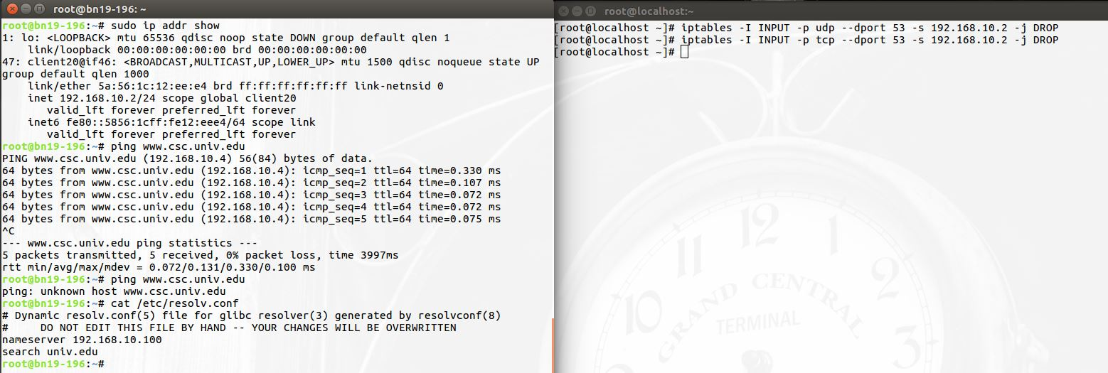



Iptables modification on the DNS server to drop incoming DNS request from a specific client (192.168.10.2) and the log message captured at the DNS server.